Poster Guideline Recommendations*

A. Visual Appearance and Content--Characteristics of the Layout

Successful poster presentations are those which achieve both coverage and clarity.

Coverage: Have you provided all the obvious information? Will a casual observer walk away understanding your major findings after a quick perusal of your material? Will a more careful reader learn enough to ask informed questions?

In addition to a title/author label and abstract, most successful posters provide brief statements of introduction, method, results, and discussion/conclusions. Ask yourself, "What would I need to know if I were viewing this material for the first time?" and then state that information clearly.

Clarity: Is the sequence of information evident? Indicate the ordering of your material with numbers, letters, or arrows, when necessary. Is the content being communicated clearly? Keep it simple. Remember, the poster is a visual representation of your study so graphs, charts, and tables are a good way to communicate information. Text should focus on the main points of your design, rationale, etc. Your poster should not be a copy of our written paper glued onto poster board. Place your major points in the poster and save the nonessential but interesting sidelights for informal discussion or your written paper. Be selective. Your final conclusions or summary should leave observers focused on a concise statement of your most important findings. Remember:
- The title, author(s), affiliation, and faculty sponsor(s) should be located at the top of the poster space, and the lettering for this section should not be less than 1 inch high
- A copy of your abstract (200 words or less) in large typescript (3/8 inch) should be placed in the upper left-hand corner of the poster board
- Bear in mind that your poster may be viewed from distances of 3 feet or more, so make sure your illustrations and text are easily readable from this distance
- Use colors to attract attention
- Use graphs/tables to convey information
- Use pictures where appropriate
- Symmetrical in appearance, i.e, right/left and top/bottom halves balanced
- Focus selectively on major findings (present the details in the printed paper available as a handout)
- Include major sections such as: Abstract, Introduction, Method, Results, Discussion/Conclusions, and References.
- Provide clear labels for each section of your presentation
- Limit the text pages
- Be sure to bring thumbtacks or pushpins with you
B. Interacting with the Audience
Posters don't stand alone. Your availability and interaction style will also influence the number of people who read your poster and talk with you about it. Always stand by your poster during your session. Use inviting behaviors to initiate conversation. Viewers appreciate having important information pointed out to them. Ask yourself:
- Do you display a professional appearance and demeanor?
- Are you responsive to questions about your research?
- Are you willing to approach people who appear interested in your poster?
- Are you able to talk about your study with different audiences?
- Do you know how your research fits into various fields of study?
- Are you enthusiastic about your research? Can you convey this to others?
C. Your Paper
You should have copies of your more detailed paper available by request or linked from a QR code

D. Sample Poster Arrangements
The following three images are sample layouts for your poster presentation. Please note that these samples are based on a 4’ x 6’ poster board, which may be different from the board available at your conference.
EXAMPLE #1:
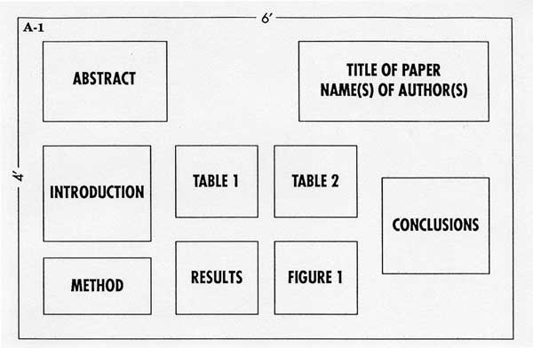

EXAMPLE #2:
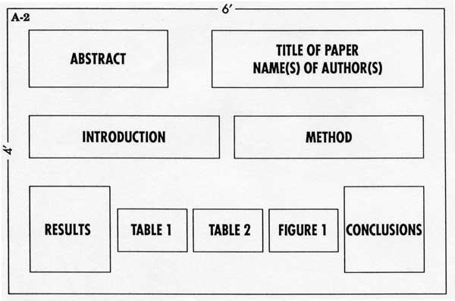
EXAMPLE #3:
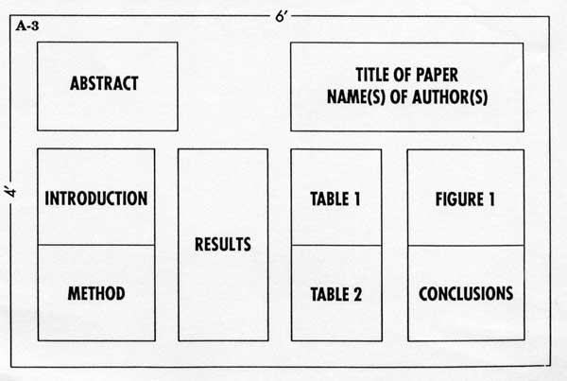

*Adapted from the Instructions for Poster Presentation at APA and from
Mitchell, J., Prevost, S. & Stoddart, R.M. (1995). And the survey says: An empirical study of effective poster presentations. Chicago: Midwestern Psychological Association Annual Conference.

